Name: ___________________________________
Summer Phone Number: ___________________________
ID Number: ___________________ 8th grade counselor: Mark.Vogt@hcps.org
Listed below are courses available for 9TH GRADE STUDENTS. No classes are guaranteed.

Graduation requirements and course descriptions can be found in the HCPS Student Educational Planning Guide: http://www.hcps.org/sepg
Your high school counselor will be based on your last name:
A to Di Bob.Winter@hcps.org Ko to Ri Kristi.Palmerino@hcps.org
Do to Kn Jennifer.Behler@hcps.org Ro to Z Mark.Szot@hcps.org

This sheet is to be completed and returned to your teacher by February 9th.
I understand that every effort will be made to build my schedule with the courses listed below. If choices are not available, my backup course selections may be substituted. List two backup courses:

Parent/guardian signature: _________________________________________ Date: _______________________________________

Each student will take eight credits, Health/Physical Education (1 credit total) has been selected for you with an X, you will need seven more X’s for a total of 8.
ENGLISH  You must choose one.  ☐ EN0101 English I  ☐ EN01W61 Honors English I (W)  SCIENCE  You must choose one.  ☐ SC0201 Biology  ☐ SC02W61 Honors Biology (W)  SOCIAL STUDIES  You must choose one.  ☐ SS0501 US History  ☐ SS05W01 Honors US History (W)  HEALTH/PHYSICAL EDUCATION every 9th grade student must take  X BKHPE9 Health (SEM) and Physical Education (SEM)  4 Total X’s | MATHEMATICS  You must choose a math class based on the class you are in this year.  ☐ EL9801 MA3002 (Counts as 2 x marks) Ramp Up Algebra Part 1 & 2 = 2 Credits (D) *  ☐ BKALGA (Counts as 2 x marks) Intro to Alg. and Alg. I (both must be taken) = 2 credits (D)  ☐ MA0201 Algebra I  ☐ MA0401 Geometry  ☐ MA0701 Algebra II  ☐ MA07W61 Honors Algebra II (W)  FINE ART  Must choose one, can take more  ☐ AR0201 Fine Art Preparation  ☐ DR1201 Drama I  ☐ MU0401 Tenor Bass I  ☐ MU0601 Treble Choir I  ☐ MU2901 Orchestra  ☐ MU2201 Symphonic Band  ☐ MU1301 Guitar Lab (LS)  Total X’s | WORLD LANGUAGE- if you have room  ☐ FL0101 French 1  ☐ FL0701 Spanish 1  Completer Classes- can choose  ☐ BE1601 Principles of Business Management and Entrepreneurship  ☐ CA0501 Principles of Art, Media, and Communication  ☐ CT0401 Agriculture  ☐ FC0101 Introduction to Food Prep  ☐ CA6001 Child Growth & Development  ELECTIVES – if you have room  ☐ BE0301 Financial Literacy & Tech.  ☐ CT81W01 GIS 1 = 1 credit (must be taking Geom. or Alg. II next year) (W)  ☐ EN0701 Journalism  ☐ EN1531 Creative Writing (LS)  Science Electives- You must be taking Honors Biology and Algebra II in grade 9 to be eligible.  ☐ BKZOMA Zoology/ Marine Science  ☐ SC1071 AP Environmental Sci W  Total x’s, add all three columns together, be sure they equal 8 when added together

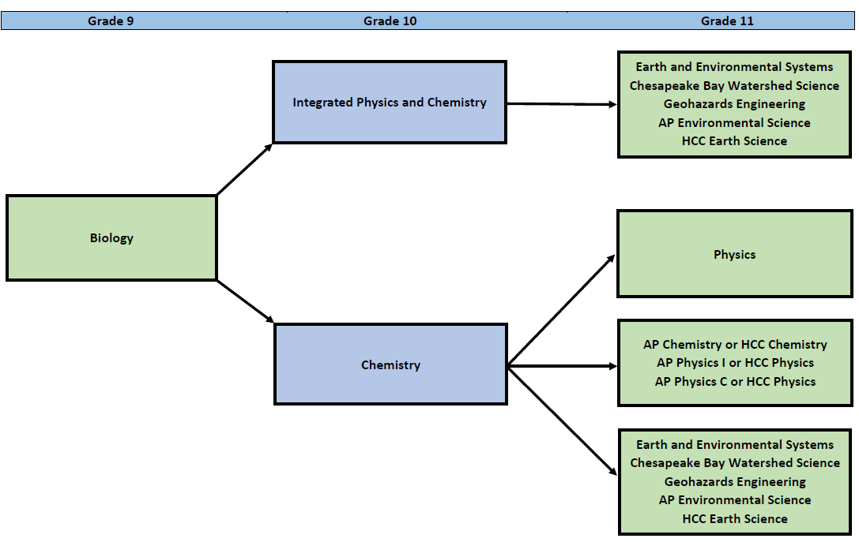
Science Progression in High School
